**Practical: Installation of Java on Unix/Linux Machine (Without VirtualBox)**

■ This guide uses WSL (Windows Subsystem for Linux) to simulate a Linux environment directly on Windows.

Step 1: Enable WSL

1. Open PowerShell as Administrator
2. Run the following command:

wsl –install

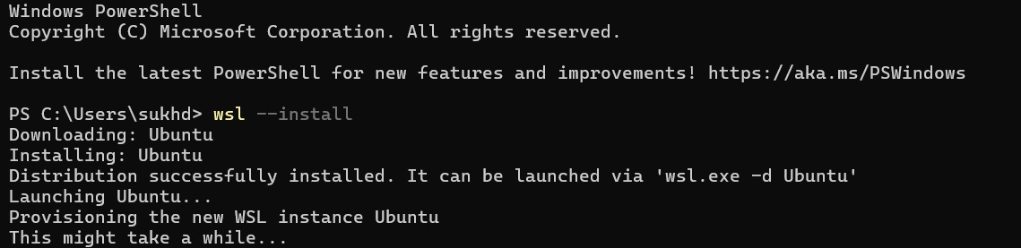

1. Restart your computer when prompted.
2. After restart, choose Ubuntu or install it from the Microsoft Store.

Step 2: Open Ubuntu (WSL)

* Search for 'Ubuntu' in Start Menu and open it.
* It will initialize and ask for a username and password.

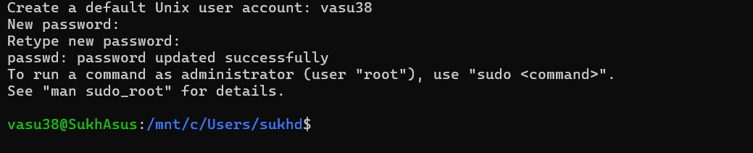

Step 3: Update the Package List

Run the following command:

sudo apt update

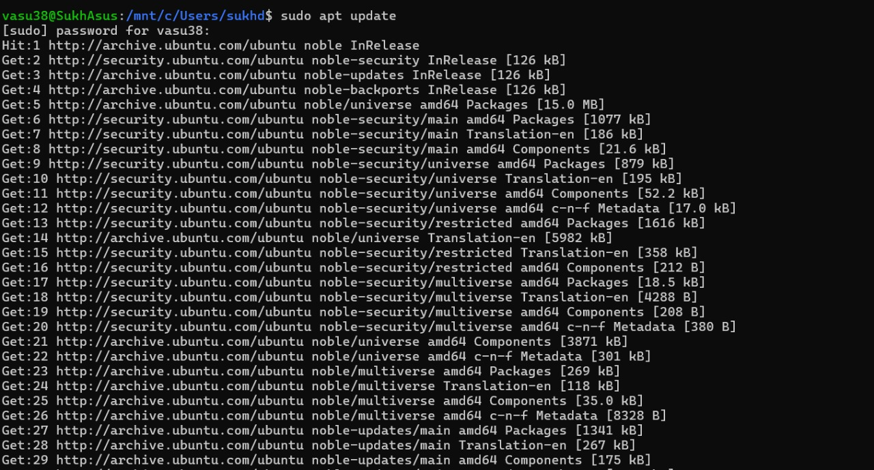

Step 4: Install Java (OpenJDK 8 or 11)

* For Java 8:

sudo apt install openjdk-8-jdk -y - For Java 11:

sudo apt install openjdk-11-jdk -y

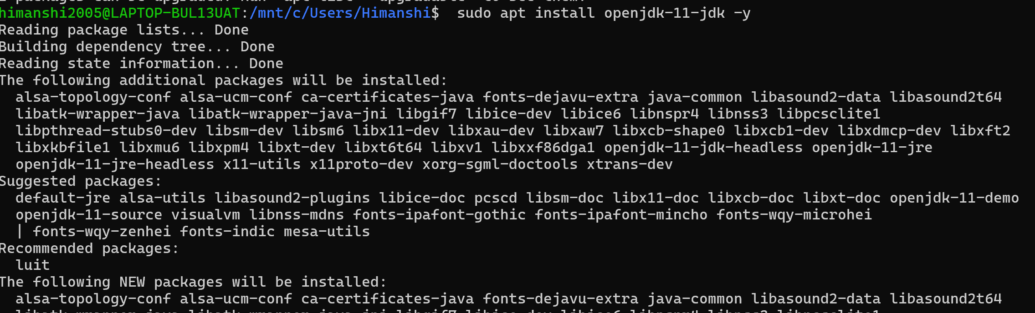

Step 5: Verify Java Installation

Run:

java -version



Step 6: Set JAVA_HOME Environment Variable (Optional)

1. Open .bashrc file:

nano ~/.bashrc



1. Add the following lines at the end:

export JAVA_HOME=/usr/lib/jvm/java-8-openjdk-amd64

export PATH=$JAVA_HOME/bin:$PATH



1. Save and exit (Ctrl+X, then Y, then Enter)
2. Reload bashrc: source ~/.bashrc
3. Verify JAVA_HOME is set:

echo $JAVA_HOME

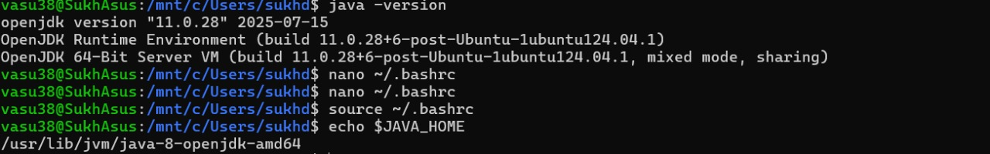

■ You now have Java installed on a Linux system simulated within Windows without using VirtualBox!